Architecture Overview
- Architecture & Design Document
- High-level architecture diagram
- Design patterns (Strategy, Repository, Dependency Injection)
- Data flow explanation
- Testing strategy
- Database Schema (SQL DDL)
- Complete relational schema
- All 4 tables: Rulesets, Rules, Conditions, EvaluationLogs
- Proper indexes and foreign keys
- Verification queries
- Domain Models
- Order input models (JSON mapping)
- Ruleset, Rule, Condition entities
- Evaluation result models
- Interface definitions
- Core Evaluation Engine
- Operator Strategies: Equals, LessThanOrEqual, GreaterThanOrEqual
- ConditionEvaluator: Evaluates individual conditions using reflection
- RulesetEvaluator: Main engine with step-by-step evaluation logging
- Data Layer
- Entity Framework Core DbContext
- Repository pattern implementation
- Clean separation of concerns
- API Controllers
- /api/evaluate - Main evaluation endpoint
- /api/rulesets/* - CRUD operations for ruleset management
- /api/health - Health check
- Comprehensive error handling
- Testing Suite
- Unit tests for operators, evaluators
- Integration tests for API endpoints
- Test for the specific JSON_1245101_N. json example

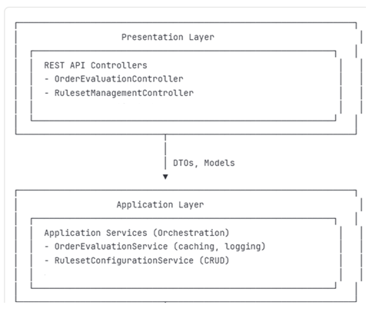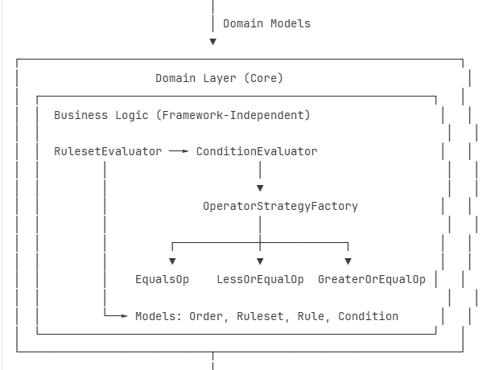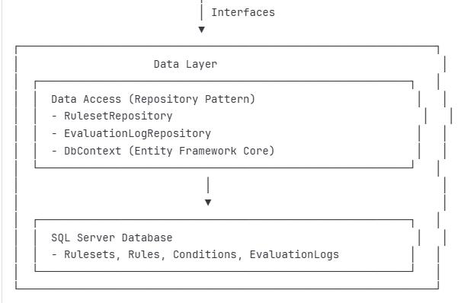
- Core Design Decisions
Strategy Pattern for Operators
To make adding new comparison operators trivial without modifying existing code.
Implementation:
csharp
public interface IOperatorStrategy
{
string OperatorName { get; }
bool Evaluate(string fieldValue, string expectedValue);
}

// Adding a new operator is just creating a new class
public class ContainsOperator : IOperatorStrategy
{
public string OperatorName => "Contains";
public bool Evaluate(string fieldValue, string expectedValue)
=> fieldValue?.Contains(expectedValue) ?? false;
}

Benefits:
- Open/Closed Principle: Open for extension, closed for modification
- Single Responsibility: Each operator has one job
- Easy Testing: Test each operator independently
- Runtime Registration: New operators discovered automatically

Repository Pattern for Data Access
Abstract database operations to enable testing and future database changes.
Implementation:

csharp
public interface IRulesetRepository
{
Task<List<Ruleset>> GetAllActiveRulesetsAsync();
Task<Ruleset> GetRulesetByIdAsync(int rulesetId);
// ... other operations
}
Benefits:
- Testability: Mock repositories for unit tests
- Database Independence: Switch from SQL Server to PostgreSQL with minimal changes
- Query Optimization: Centralized location for performance tuning
- Transaction Management: Consistent data access patterns
Reflection-Based Field Resolution
Avoid hard-coded field mappings that require code changes for new order attributes.
Implementation:
csharp
private string ExtractFieldValue(Order order, string fieldName)
{
var property = typeof(Order).GetProperty(fieldName,
BindingFlags.Public | BindingFlags.Instance | BindingFlags.IgnoreCase);

return property?.GetValue(order)?.ToString();
}
Benefits:
- Flexibility: New order fields work immediately
- Configuration-Driven: Add fields in config, not code
- Maintainability: Less code to maintain
- Case-Insensitive: Handles variations in field naming
Layered Caching Strategy
Rulesets change infrequently but are read constantly.
Implementation:
csharp
public async Task<List<Ruleset>> GetActiveRulesetsAsync()
{
// Try cache first
if (_cache.TryGetValue(RULESET_CACHE_KEY, out List<Ruleset> cached))
return cached;

// Load from database
var rulesets = await _rulesetRepository.GetAllActiveRulesetsAsync();

// Cache with expiration
_cache.Set(RULESET_CACHE_KEY, rulesets,
TimeSpan.FromMinutes(15));

return rulesets;
}
Benefits:
- Performance: 1000x faster than database queries
- Scalability: Reduces database load by 99%+
- Consistency: Cache invalidation on updates
- Configurable: TTL adjustable per environment

- Code Quality Measures

1. SOLID Principles Applied
Principle | Implementation
Single Responsibility | Each class has one reason to change (e.g., ConditionEvaluator only evaluates conditions)
Open/Closed | Strategy pattern allows extension without modification
Liskov Substitution | All IOperatorStrategy implementations are interchangeable
Interface Segregation | Small, focused interfaces (e.g., IRulesetRepository vs. generic repository)
Dependency Inversion | Core logic depends on abstractions, not implementations

2. Design Patterns Used
Pattern | Purpose | Location
Strategy | Pluggable operators | IOperatorStrategy implementations
Repository | Abstract data access | IRulesetRepository, IEvaluationLogRepository
Factory | Create operator instances | OperatorStrategyFactory
Dependency Injection | Loose coupling | Throughout (constructor injection)
Chain of Responsibility | Sequential rule evaluation | RulesetEvaluator.Evaluate()

